Assignment VI

- Given n nodes with an average degree d, you can make a graph where each node had exactly d edges and where each node n_{i} is connected to its d closest neighbors. Such a graph is called a regular graph.

    - If n=5 and d=3 it is impossible to construct such a graph. Why?
    - Explain the general case where a regular graph cannot be constructed based on the properties / relationship of n and d.
    - Prove the statement that you make in (b). (12)

- In the graph below, there are 16 nodes. The graph is undirected and regularly connected where the degree of each node d=3. (12)

I have chosen to randomly rewire these edges as shown in the table. Each row represents a rewire, where the original edge is removed and replaced with the new edge. For example, if the original edge is a,b and the new edge is g,j that means I removed the existing edge between a and b and added in an edge from g to j.
 | 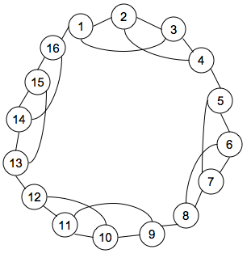
  Original Edge | New Edge
  1,3 | 3,14
  5,7 | 15,9
  16,1 | 2,6
  2,3 | 5,3
  4,5 | 5,8
  6,7 | 9,7
  8,9 | 9,3
  10,11 | 2,3
  12,13 | 8,4

- What is the average degree after the graph has been rewired?
- How did I "randomly" determine which edges to add in?
- If I were to rewire one more pair, what edge follows in the pattern and why is thalt a problem?

- Consider the following small world model. There are n nodes arranged on a directed ring. Every node is connected to the one on its left with a directed link of unit length. We add a new central point to the network, and connect it with every other vertex on the circle with probability p, using an undirected link of length 1/2. Essentially, this means that we select some vertices with probability p and then connect them with an undirected link of length 1.

    - Compute the probability P(l, k) that the shortest path from one vertex to another is l when the distance between the vertices along the ring is k. (Hint: ∑_{l=1…k} P(l, k) = 1)
    - Find the distribution P(l) of the shortest path between pairs of vertices.
Compute the average shortest path between the vertices of the graph (12)

- Find the characteristic path length of a Moore graph with n nodes each having a degree k. If you do not know how a Moore graph looks, you need to check it from the literature. This is a part of your assignment. Derive the special case when k=2. (18)

- Modify the BA model of preferential attachment to tune the clustering coefficient. Show with illustrations how your scheme works. (18)

